|  |
| --- |
| CYBER SECURITY PROJECT REPORT |
| Project on Web Penetration  [Footprinting and Brute-Force of Wordpress website] |
|  |
|  |



CYBER SECURITY PROJECT REPORT



BY,

CHIRAG RADHAKRISHNA

CYBER SECURITY & ETHICAL HACKING BATCH-18

PROJECT ON WEB PENETRATION

FOOTPRINTING AND BRUTE-FORCE OF WORDPRESS WEBSITE

**TABLE OF CONTENTS**

|  |  |  |
| --- | --- | --- |
| **SL.NO** | **TOPIC** | **PG.NO** |
| 1. | ABSTRACT | 5 |
| 2. | INTRODUCTION | 6-11 |
| 3. | SOFTWARE | 12-13 |
| 4. | PROJECT DESCRIPTION & PROOF OF CONCEPT | 14-36 |
| 5. | INFERENCE | 37 |
| 6. | CONCLUSION | 38 |
| 7. | ACKNOWLEDGEMENT | 39 |

**TABLE OF FIGURES/GRAPHS**

|  |  |  |
| --- | --- | --- |
| **SL.NO** | **PARTICULARS** | **PG.NO** |
| **1** | Cyber victim density chart per country | **9** |
| **2** | Cyber-crimes in India | **10** |
| **3** | Rate of increase in cyber-crime activity in India | **10** |
| **4** | Damages incurred due to cyber-crimes on a globally | **11** |
| **5** | Insider Threats | **11** |

**ABSTRACT**

One will definitely agree about the fact that technology has revolutionized and simplified the way we live. The development of computing and information technology has resulted in performing tasks in a simple manner, obtaining information within minutes and a host of other activities. As a result we can say that the computer is one of the most significant inventions in history.

We give importance to how a computer works, what can be done to improve the performance, provisions for new applications, which all have a positive impact. However, these positive characteristics tend to mask the potential weaknesses of a computer. Nothing in this world is perfect. Everything has a loophole/flaw/drawback or whatever you want to call it. Likewise, a computer has one major flaw which could have devastating consequences, SECURITY.

Computer Security is one aspect regarding computers, which is gaining importance at a rapid pace in the present world. Computer security is a key aspect of computing as a breach in computer security can lead to loss of sensitive information and misuse of credit card data, to name a few. Security has nothing to do with the visual appeal or the ‘fancy’ aspects of a computer. But it is a vital aspect of a computer that protects us from cyber-crimes.

Hence, we need to understand the importance of security in computers and take the necessary steps to keep our computer secure.

**INTRODUCTION**

**What is a threat?**

A threat is a potential violation of security. When a threat is actually executed, it becomes an attack. Those who execute such actions, or cause them to be executed are called attackers.

Some of the common threats are:

1. Computer Viruses: are malicious codes that cause damage to data and files on a system. Two other similar programs that have a similar impact like a computer virus are:

* Worm- is a self-replicating program which occupies the entire disk space/memory. It replicates until the complete disk space has been occupied.
* Trojan Horse- a program that appears harmless but actually performs malicious functions such as deleting/damaging files.

1. Spyware: software that is installed on your computer to spy on your activities and report the corresponding data to people who are willing to pay for it.
2. Adware: These are programs that deliver unwanted advertisements to your computer. Consumes your network bandwidth. Is similar to spyware, although it may be installed with your consent.
3. Spamming: refers to the sending of bulk-mail by an identified/unidentified source. With respect to the malicious form, the attacker keeps on sending bulk mail until the user’s mail-server runs out of disk space.
4. PC Intrusion: Occurs when the computer is connected to the internet. The different forms of PC Intrusion are:

* Sweeper Attack: A malicious program used by hackers. Deletes all data from the system.
* Denial of Services: This type of attack eats up all the resources of a system and the system/applications come to a halt.
* Password Guessing: Most hackers crack or guess passwords of system accounts and gain entry into remote computer systems and then use it for causing damages in one or another form.

1. Pharming: is an attack in which a hacker attempts to redirect a website’s traffic to another, bogus website.
2. Phishing: attacker sends a fraudulent message designed to trick a person into revealing sensitive information to the attacker.

**System Security-**

Computer security is the ability of the system to protect information and system resources with respect to confidentiality and integrity.

Basic components of a computer security:

Computer security is frequently associated with three core areas, which can be conveniently by the acronym “CIA”-

* Confidentiality- Ensuring that information is not accessed by unauthorized persons.
* Integrity- Ensuring that information is not accessed by unauthorized persons in a way that is not detectable by authorized users.
* Authentication- Ensuring that users are the persons they claim to be.

Computer security is not restricted to these three broad concepts. Additional ideas that are often considered part of the taxonomy of computer security include:

* Access control
* Nonrepudiation
* Availability
* Privacy

**Hacking:**

It is referred to as the act of compromising digital devices and networks through unauthorized access to an account or computer system. Hacking is not always a malicious act, but it is most commonly associated with illegal activity and data theft by cyber criminals.

Ethical Hacking- An attempt to hack computer/network with the written permission of the assets owner. An ethical hacker attempts to find weak-links, vulnerabilities that malicious hackers can potentially exploit. This is referred to as penetration testing.

There are 3 types of hackers-

1. Black Hat Hacker- An individual who manipulates systems to function in a way they were not intended with the intention of doing things that are unethical.
2. White Hat Hacker- An individual that manipulates systems to function in a way they were not intended to with the intention of exposing flaws so they can be corrected.
3. Gray Hat Hacker- An individual who does things that are not ethical but they do not do them with the malicious intent that a Black Hat would. For example, accessing a computer system without permission and later notifying the company so that the problem can be fixed.

**Why is cyber security needed?**

With the advancement in technology, there is also a need to ensure that the security of a computer is also in sync with these advancements in order to avoid malicious attempts to access sensitive information.

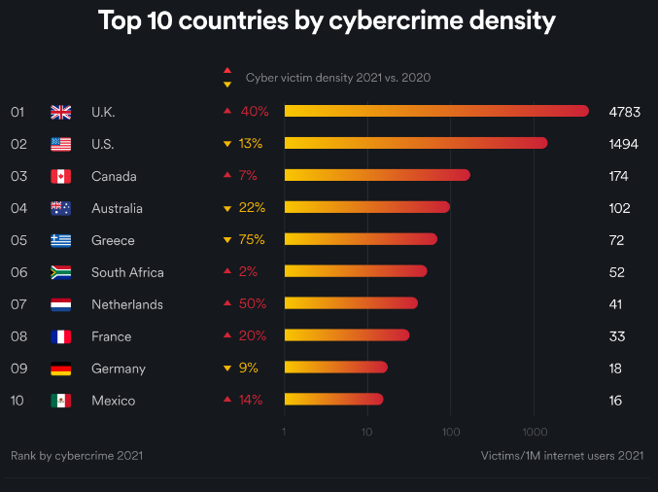

Fig 1: Cyber victim density chart per country

From Fig 1, it is evident that cyber-crimes take place across the world. The numbers state that it is a serious issue which has to be dealt with in a sensitive manner.

Security is similar to coal in an engine of a train. Despite coal not contributing to the design or the visual appeal of a train, it is a vital clog in the train’s engine without which the train cannot operate. The same reasoning can be applied to security. Hence we need cyber security (reliable measures/frameworks) to combat these crimes and improve the efficiency of computers.

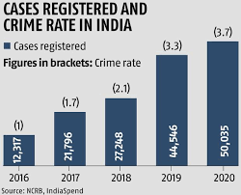

Fig 2: Cyber-crimes in India

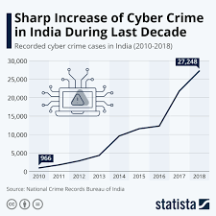

Fig 3: Rate of increase in cyber-crime activity in India

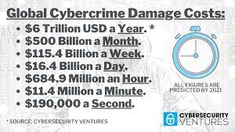

Fig 4: Damages incurred due to cyber-crimes globally

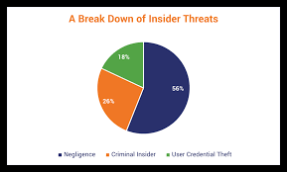

Fig 5: Insider Threats

**SOFTWARE**

For our project, we have made use of two virtual machines to carry out the respective operations.

Virtual Machine: An Operating System (OS) that runs on software that emulates hardware. This allows one physical computer to run multiple Operating Systems (OS) consecutively.

The two virtual machines employed in the project are:

Kali Linux: Kali Linux is a Debian-derived Linux distribution designed for digital forensics and penetration testing. It is maintained and funded by Offensive Security.

Wordpress 32-bit VM: helps access the Wordpress website through the Wordpress server and helps us hack into the admin account by providing a connection to Kali Linux.

Now we are going to run these two virtual machines on our Windows 10 Operating System. As a result we need a framework to contain and run these two virtual machines. For this purpose, we are using Oracle VM Virtual Box.

Oracle VM Virtual Box is cross-platform virtualization software. It allows users to extend their existing computer to run multiple operating systems including Microsoft Windows, Mac OS X, Linux, and Oracle Solaris, at the same time.

For footprinting and brute-forcing the Wordpress website, we have set up the lab which comprises of the following components:

Kali Linux VM.

Wordpress host which helps run Wordpress website.

Network Adapters that help connect the two virtual machines.

PROJECT DESCRIPTION AND PROOF OF CONCEPT

At first, we implement some basic commands on the Kali Linux,

We implement these basic commands using the terminal. The terminal is a command-line feature similar to Windows command prompt.

Simple methods we have implemented include listing files and directories, changing directories and creation and deletion of directories.

Proof of concept:

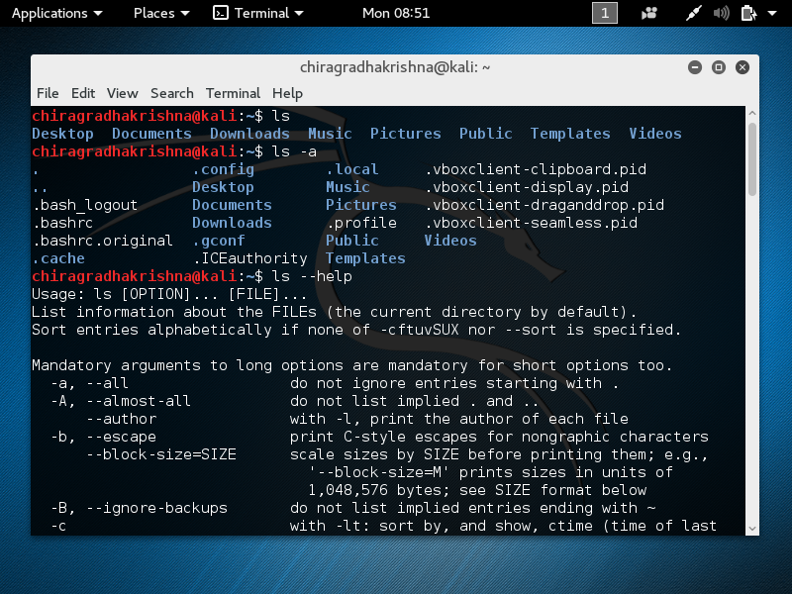

The ls command allows you to list the files and subdirectories contained within the current directory. The documentation of various commands in Kali Linux can be viewed using the - -help option. The ls –a command will help list all the hidden files.

* The cd command enables us to navigate through the file system.

Proof of Concept:

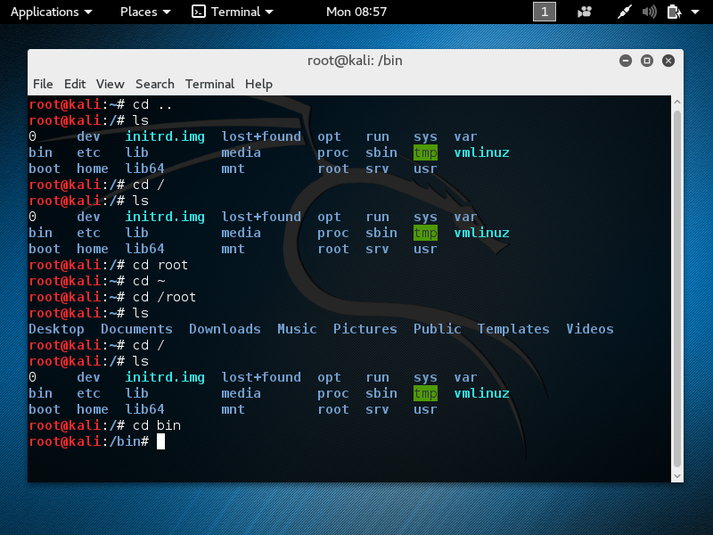

We can use the cd command to traverse the file system as demonstrated above.

Top of the file system is the root directory which is indicate by ‘/’. All files can be eventually traced back to the root. The password files that we use to hack the Wordpress website, their ultimate ancestor is the /.

Each directory comprises of built-in sub directories. We can create and remove directories using mkdir and rm commands.

Proof of concept:

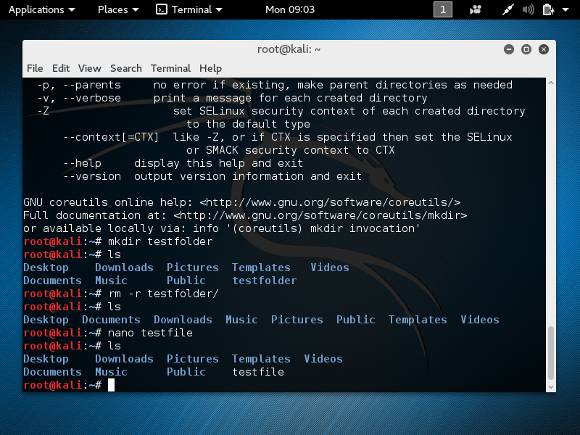

We have created and deleted the testfolder directory using the mkdir and rm commands.

* Pinging Messages:

Using the ifconfig method we obtain the important networking information.

We establish a host-only network connection. This allows us to our virtual machine to communicate with the host computer or with another virtual machine.

Proof of concept:

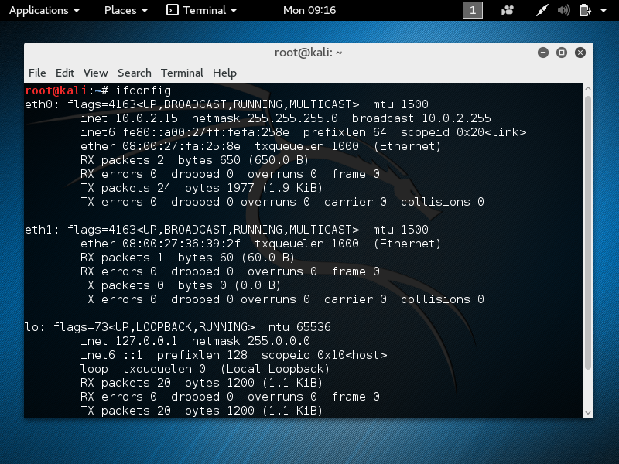

Eth1 specifies the information of the host-only network to which the Kali Linux is connected to.

We can check the connection between the virtual machine and host computer by pinging messages.

Proof of concept:

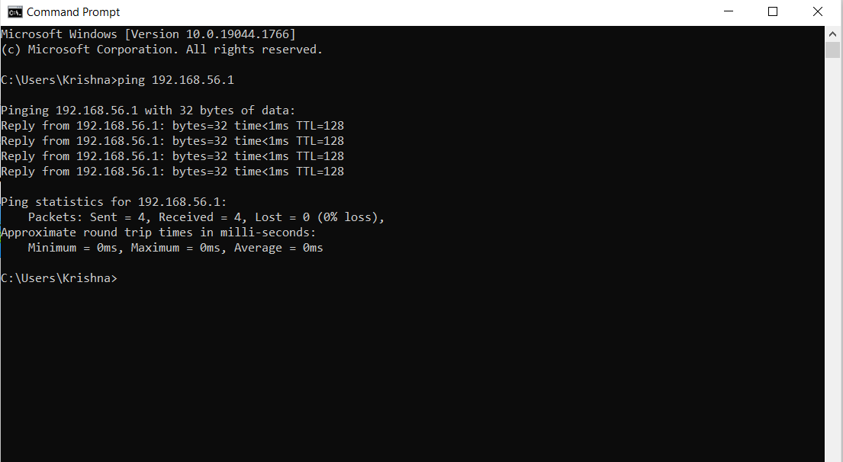

Here 192.168.56.1 is the IP address of Kali Linux virtual machine on the host-only network. We have obtained a reply from the virtual machine on executing the command ping 192.168.56.1 on the command prompt of the host computer.

The reply indicates that communication between the Kali Linux virtual machine and the host computer is working.

* Footprinting:

It’s the process of gathering data about a certain target, usually for the purpose of exploiting that information to compromise the target. Some of the information collected might be IP ranges, system naming convention, software, open ports, services running and user account names. This information can vary depending on the type of attack.

Performing Footprinting using Nmap-

Nmap is used to discover hosts and services on a computer network by sending packets and analyzing the responses.

First we see check the different host-only networks that are available for the Virtual Box, then we can perform network discovery.

Proof of concept:

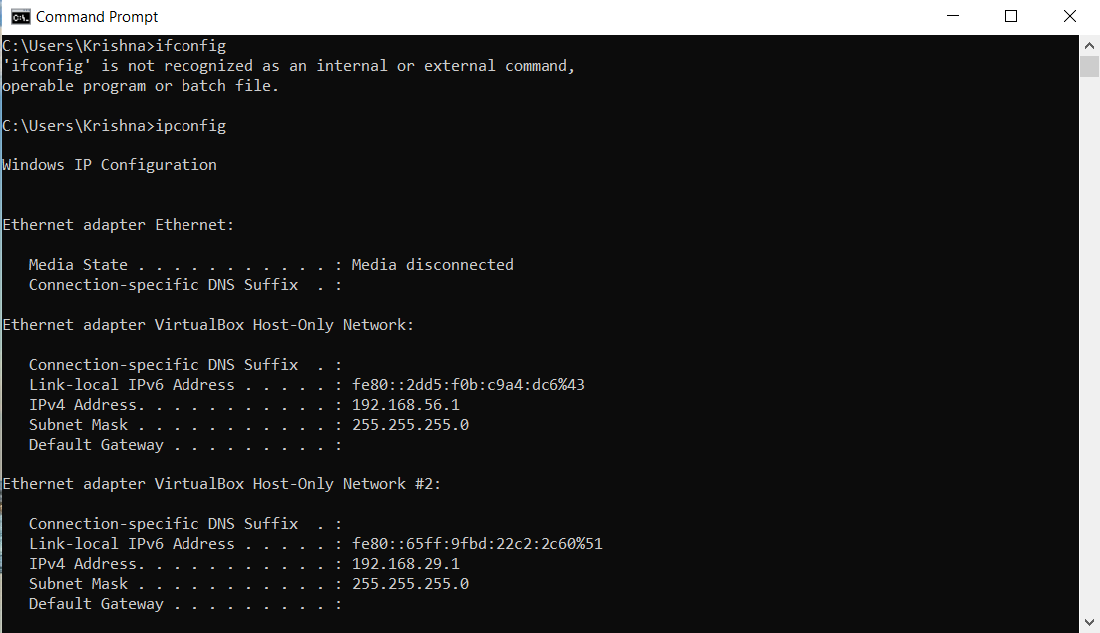

To obtain information about the hosts on the network 192.168.29.1, we use the command:

Nmap –sP 192.168.29.1/24

Where sP is ping scan.

/24 implies that we are going to be scanning the entire network.

On executing this command, we are going to get the IP addresses [computers] that are on the particular network.

Proof of concept:

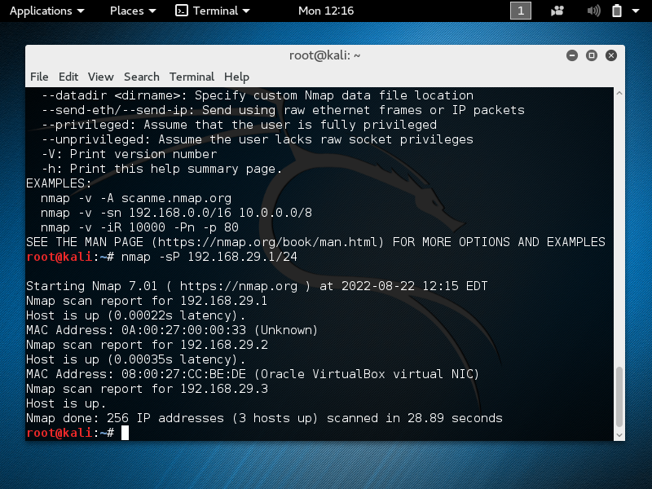

On executing the command, we find a total of 3 hosts [computers]. This information can be saved for purpose of Footprinting.

After obtaining this information, we can see the number of open ports on a particular host using the command:

Nmap –sS -A 192.168.29.2

Where: -sS implies stealth scan

-A enables OS fingerprinting inversion detection

192.168.29.2: Is the host for which we try to obtain information.

By running this command, we can obtain information such as port number that is open, state, service and version. Also we can obtain the type of device, the OS it is running, the OS details and trace-routes.

Hence we can obtain the ports that are vulnerable or those that can be attacked and then we can save this information.

----------------------------------------------------------------------------------------------------

Hence we were able to perform network discovery and obtain information about particular hosts that are connected to network 192.168.29.1.

Using this information, attacks can be conducted against the network.

Hacking WordPress Website:

The WordPress host is downloaded and imported to Oracle VM Virtual Box. Then we ensure that the WordPress host and the Kali Linux VM are connected to the same network.

We then power on the WordPress host [VM]. When the command ifconfig is executed, we obtain the IP address of the VM.

Proof of concept:

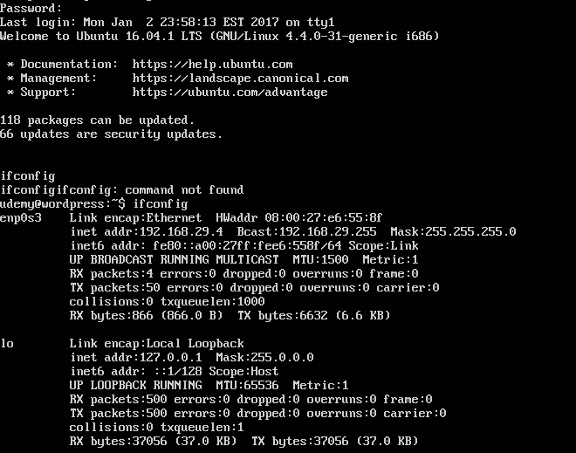

The IP address as seen under enp0s3 is 192.168.29.4.

Using this IP address, we check to see if the corresponding website is displayed, when we type <http://192.168.29.4> in the address bar of a browser on the host computer.

Proof of concept:

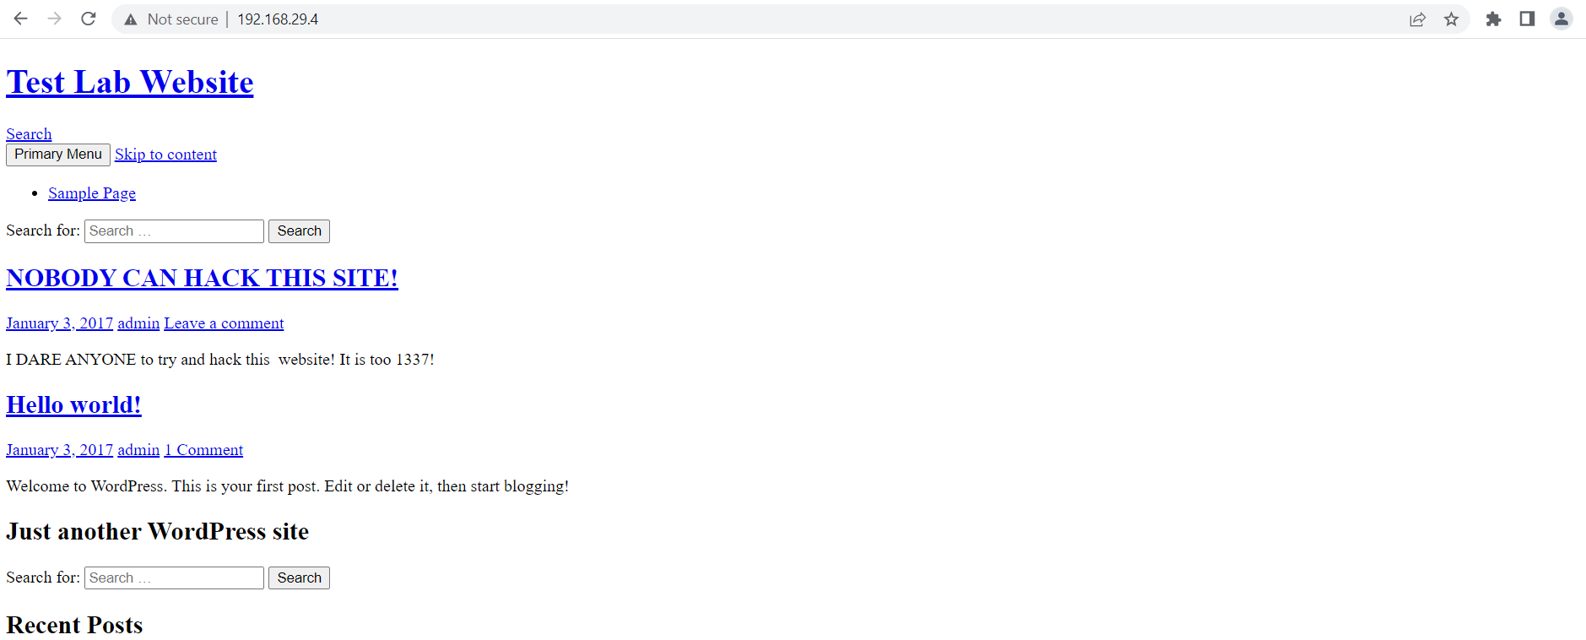

Hence we are able to generate the website.

Before we hack into this website, we need to ensure that the two virtual machines have connectivity between each other. For this, we have placed on the same host-only network. To check connectivity, we can ping the IP address of the WordPress server.

Proof of concept:

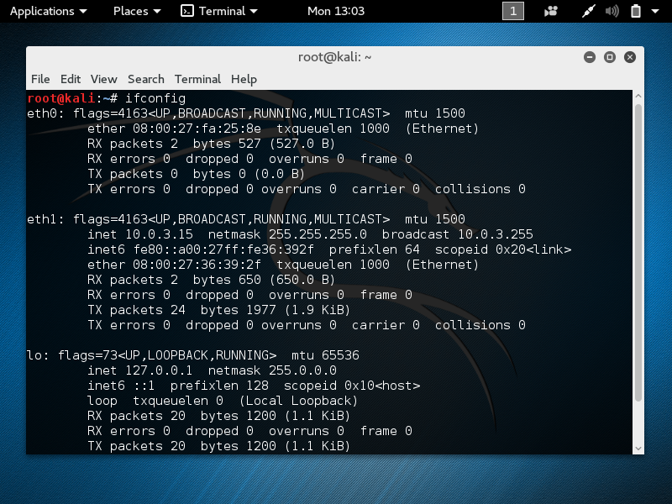

By executing ifconfig, we can see that there is no conflict between Kali Linux and the WordPress server.

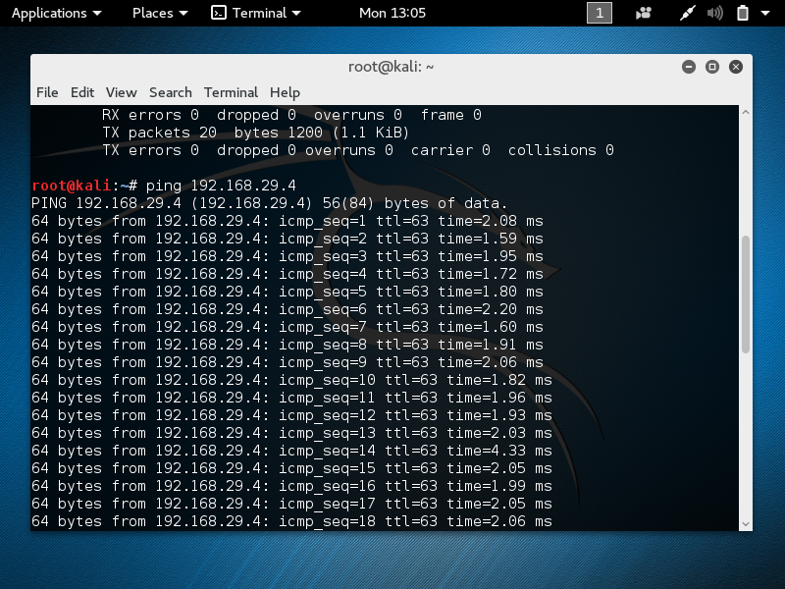

Since we obtain a response, the virtual machines are connected to each other.

* Footprinting the WordPress website:

Footprinting is achieved using the wpscan tool.

Kali Linux is connected to the Internet. That is the network adapter attached to NAT.

The wpscan tool can be used to find out existing users who have logged onto the website, their passwords and user IDs and also the number of vulnerabilities in the website.

First step is to update the wpscan database-

Command: wpscan - -update

Next, we switched to the host-only network to connect to the WordPress server.

Second step:

Command: wpscan - -url <http://192.168.29.4>

Proof of concept:

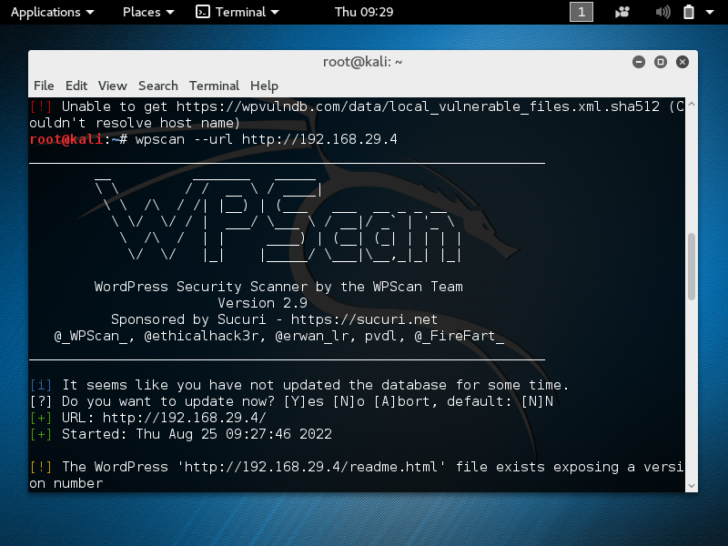

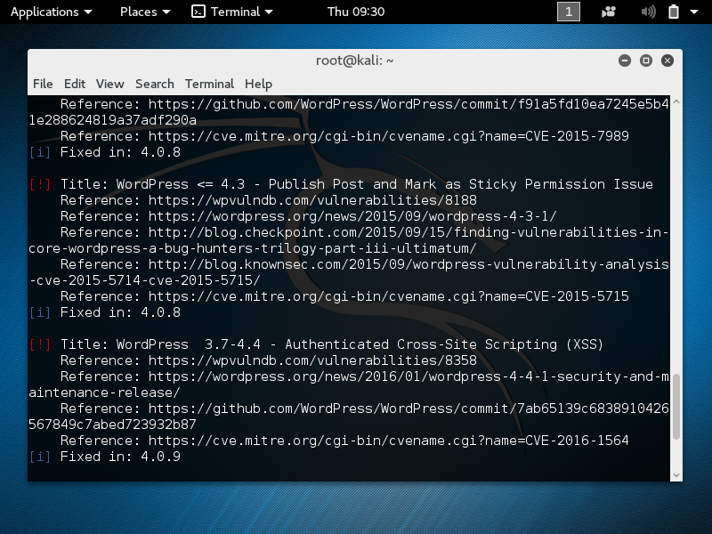

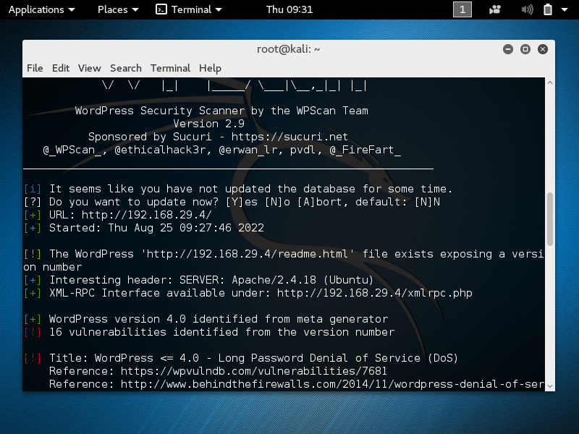

Here, we can see the version of Apache, that is the server and we can also the see the URL.

XML RPC interface enables us to run brute force attacks.

The current version has 16 vulnerabilities.

Information regarding the vulnerabilities can be obtained by clicking on the hyperlinks associated with each reference associated with it.

For this we will have to connect the Kali Linux VM to the Internet [NAT].

Proof of concept:

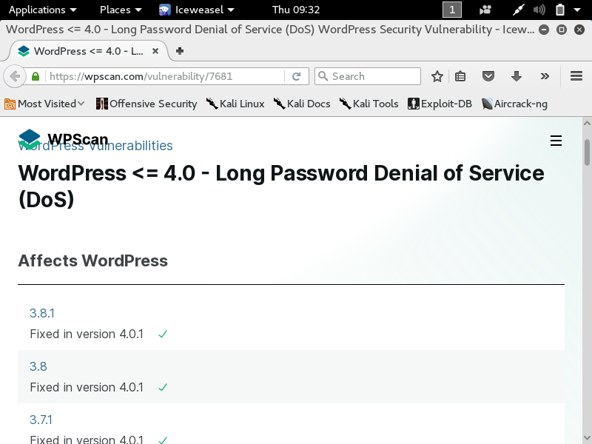

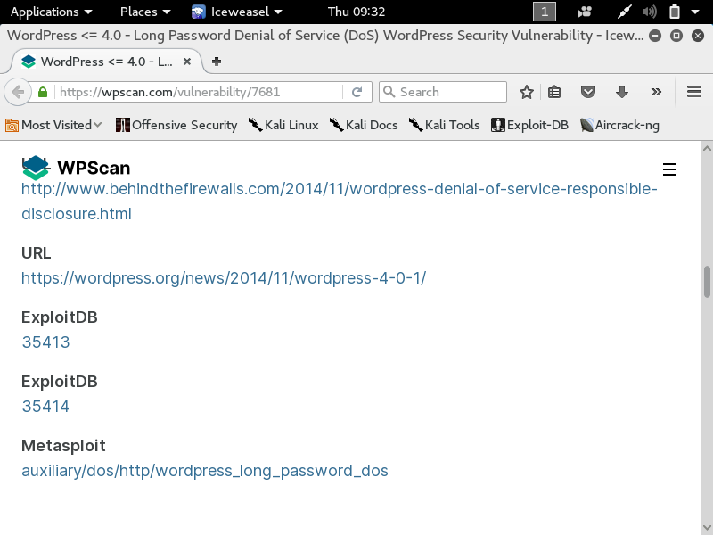

We can see the versions of WordPress that are affected by the password Denial of Service (DoS). There is an exploit provided by exploit database which we can run to attack this vulnerability.

Likewise, the different references will be able to provide us with different information.

Also the version number which has the vulnerability resolved is mentioned after the list of references.

An alternate method can be to store the information regarding the website in a file.

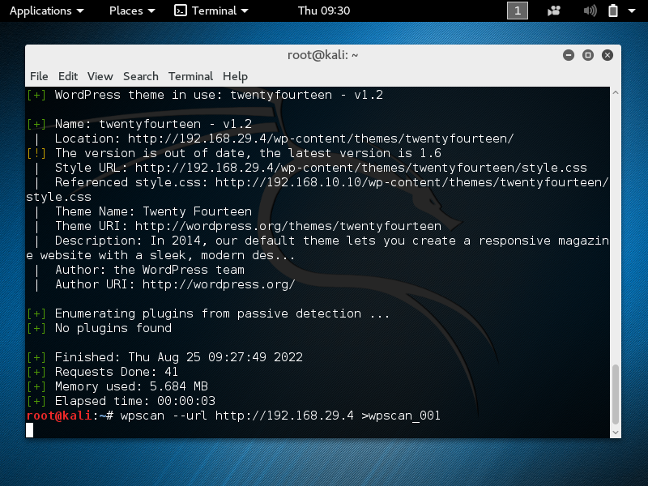

Thus we can store the information in a file.

Third step is to find the user accounts that exist on the server (website).

Command: wpscan - -url <http://192.168.29.4> - -enumerate u

Proof of concept:

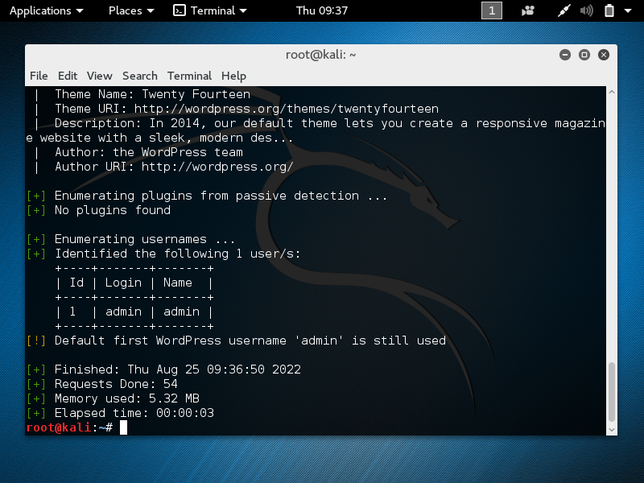

Hence we find a user ‘admin’ with login admin.

Likewise we can also see the plugins that are installed on this website.

This can be done using the command:

wpscan - -url <http://192.168.29.4> - -enumerate p

This information can be stored in files.

Proof of concept:

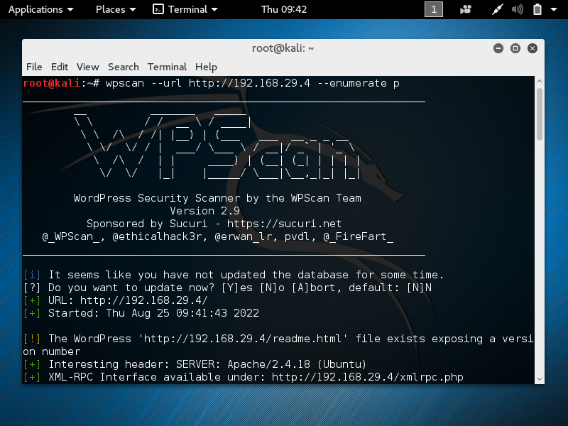

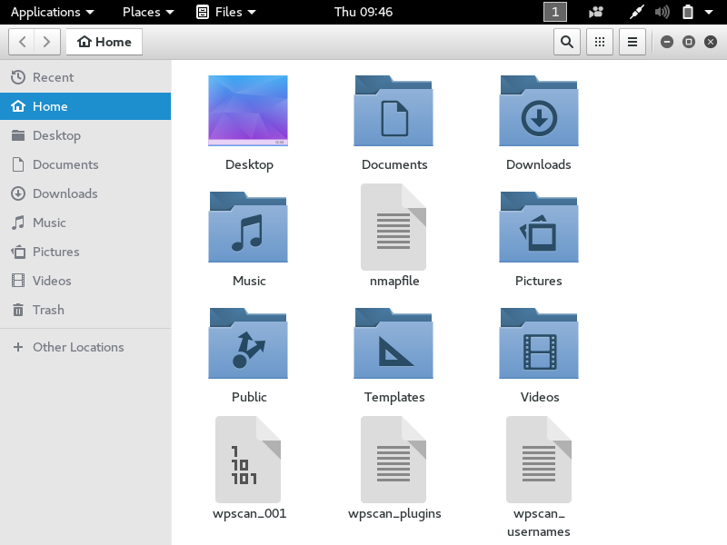

Wpscan_001: contains information about the website.

Wpscan_usernames: contains the names of existing users.

Wpscan_plugins: contains the list of website plugins.

Fourth Step: To find the password of admin and hack into admin account.

To find the password, we can make use of password files.

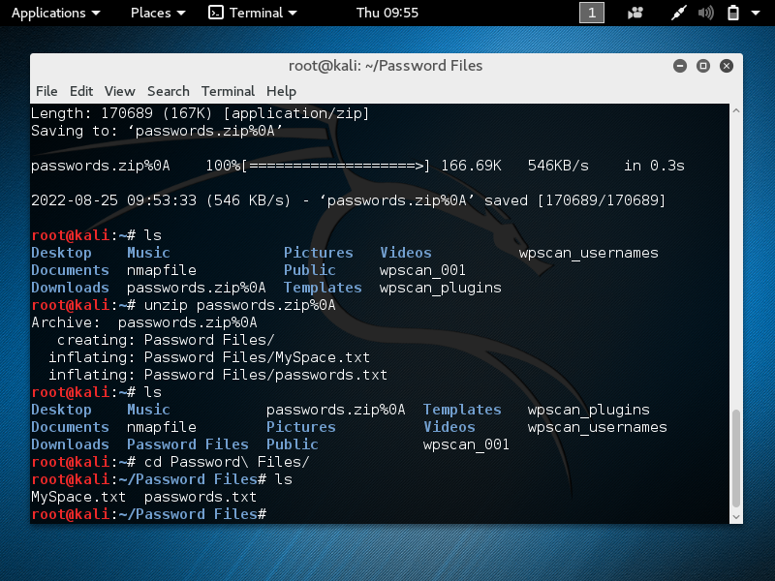

Password files can be downloaded from the Internet. Once the download is complete, we switch back to the host-only network that connects Kali Linux and the WordPress server.

We can cross-check the connection by pinging the web server.

Proof of concept:

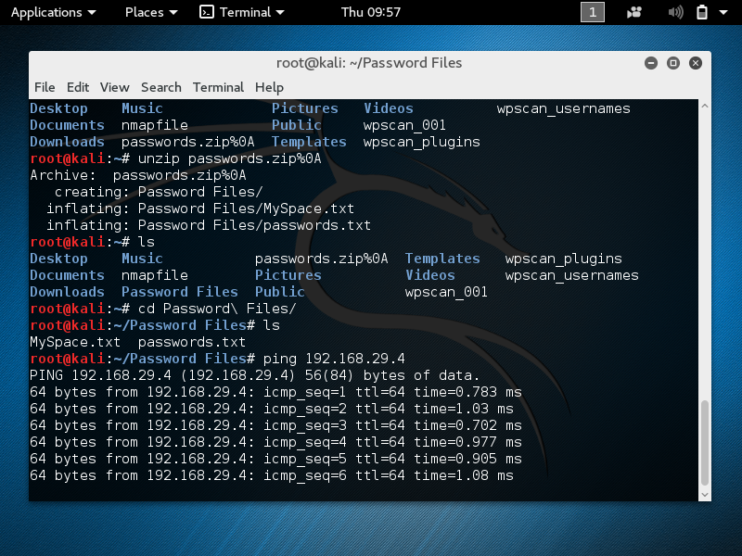

Now we use the password file passwords.txt to try and obtain a match for the admin password.

This is termed as ‘Brute-Force’ of the WordPress website. To perform this operation we employ wpscan.

Command:

wpscan - -url <http://192.168.29.4> - -wordlist ~/Password\ Files/passwords.txt

- -username admin

This command will search the passwords in the passwords.txt file and will try to obtain the password that matches the password of the admin.

Proof of concept:

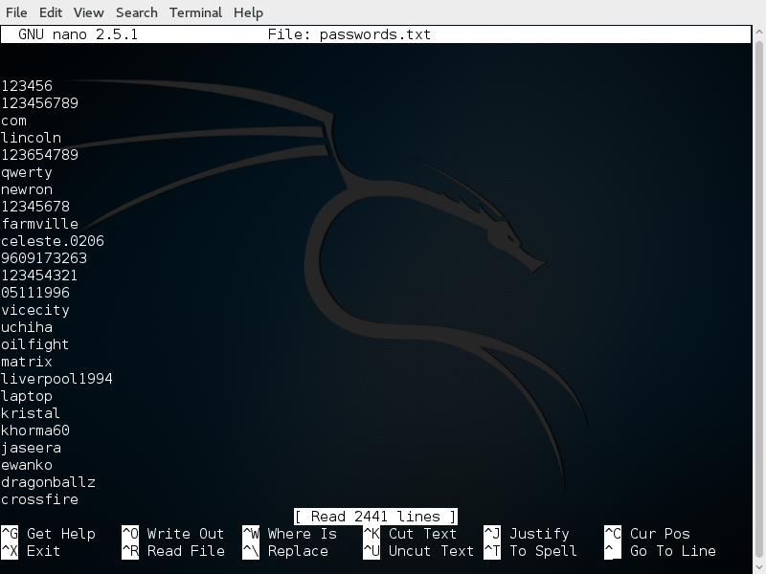

The contents of the passwords.txt file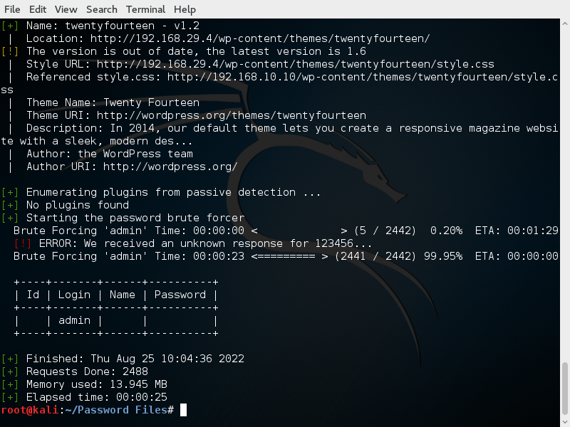

On observing the table, it is evident that no password match could be made. Hence we require a larger password file. We perform the same operation using the Myspace.txt file.

wpscan - -url <http://192.168.29.4> - -wordlist ~/Password\ Files/MySpace.txt

- -username admin

Proof of concept:

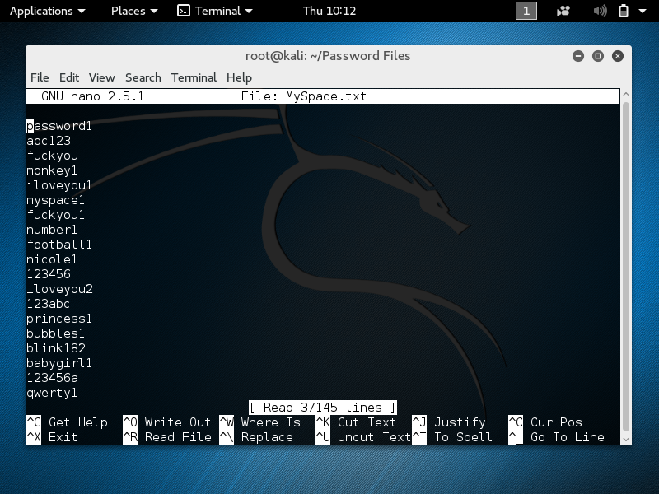

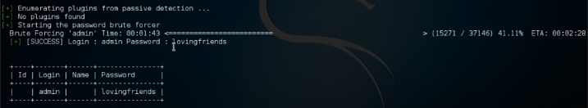

The match has been found since we considered a much larger password file.

MySpace.txt contains approximately 35000 passwords more than passwords.txt.

Now we have obtained the admin password, we can hack into the account.

Proof of concept:

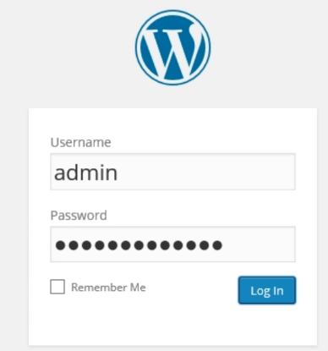

Logging in with admin credentials

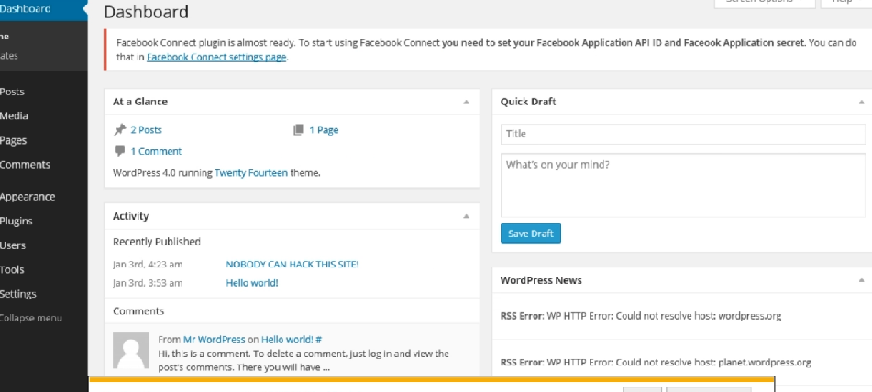

INFERENCE

We were able to penetrate into the WordPress server by taking advantage of the vulnerabilities. We were able to obtain information regarding different aspects of the website server and find the user accounts and their respective passwords.

Since the password can be any combination of numbers, letters, spaces and special characters, we need a large number of password matches to obtain the correct password of the user account that will lead to hacking of the respective account.

CONCLUSION

Our project has shown the possible vulnerabilities a website/ web server can potentially have. Also we have highlighted how sensitive information can be obtained and how it can be used for unethical purposes. Hence this highlights the importance of a reliable, efficient security system and further showcases the significance of cyber security.

In addition to enhancing the visual appeal, application capabilities of a computer, we also need to enhance the security structure to prevent cyber-crimes.

ACKNOWLEDGEMENT

I would like to thank my project teammate for his co-operation and timely inputs that led to the successful completion of this project.

I would like to express my sincere gratitude to Mr. Altaf for introducing me to Cyber Security concepts, providing timely inputs and invaluable guidance and for giving me an opportunity to work on a project.

I would like to express my sincere gratitude to Mr. Ashwin for providing the necessary resources and reference materials that were of assistance in the successful completion of this project.

I would like to thank Knowledge Solutions India for providing a platform for interactive learning and providing the opportunity to work on a Cyber Security project.